Illinois Institute of Technology

**The Starbucks Order from Hell**

**Version 1.0 / Last Update: 10-29-19**

**Game Bible**

Dammeier, Cole

Orr, Justin

Crowe, Patrick

Cantu, Luis Roberto

**HUM 372-01: Interactive Storytelling**

Professor Carly A. Kocurek

October 30, 2019

**Table of Contents**

|  |  |
| --- | --- |
| Setting …………………………………………………………………….. | 2 |
| Storylines/Arcs/Plot Development ………………………………………... | 3 - 7 |
| History …………………………………………………………………….. | 8 - 9 |
| Magic/Technology/Science ………………………………………………... | 10 - 11 |
| Cultures/Societies …………………………………………………………. | 12 |
| Characters …………………………………………………………………. | 13 - 15 |
| Dialogue ………………………………………………………………….... | 16 - 22 |
| Mechanics/Interactions ……………………………………………………. | 23 |
|  |  |
|  |  |

**Setting:**

* The afterlife doesn’t take souls somewhere physically different. Instead, people wake up in the same place they died, only the living are invisible and all the beings in the afterlife suddenly are visible. Death is just like passing through a layer of mosquito netting. On one side exist all the demons and the dead. On the other side are the living. When people die, they fall through the netting and “land” in the same place they started, only everyone living is “filtered” out of existence.
* Everything physical and grounded to the location is considered sacred. Sacred elements exist in the land of the living and in the afterlife, they aren’t filtered by the “mosquito netting”. So, buildings and architecture, as well as landscapes exist simultaneously in Hell and life, but items, vehicles, and beings cannot, they are filtered. That, however, does not mean that items, vehicles, and beings cannot be transported from one reality to another. Demonic magic can transport thing to Hell through the filter of the living
  + Demons have stolen cars, cabs, and even trains to make the infrastructure of Chicago Hell more reliable.
* Hell is a place where both the living and the dead can exist. The dead are stuck there, brought in on the L by Charon, who has picked up a job as an L conductor after piloting boats down the River Styx for millenia. Souls cannot return to the land of the living because their bodies are not strong enough to protect their souls against the filter.
* Hell is accessible through the Cloud Gate sculpture, Lucifer’s personal preference as Chicago’s gateway to Hell. Oddly enough though, both can be reached through the Cloud Gate sculpture by the living, but all the immediately dead are actually sent to Hell first. Hell is actually just the first stage of the afterlife for many, it just gets its name because it’s overcrowded, dumpy, and the transition from Hell’s stage to the following stages takes basically an eternity. Most people have to wait millenia before their paperwork is finally processed and they can take Charon’s L to Heaven, Valhalla, etc.
* The Sears Tower, Lucifer’s main office, has been modified to hold 666 floors, each of which are roamed by terrible demons looking to both help and hurt
* Due to overcrowding, there’s always traffic, the buses are always late, and the lines are a block long.

**Storylines/Arcs/Plot Development:**

* *ONE ENDING: RECEIVE MESSAGE FROM Lucifer AND JUST SAY NO!
* For the interaction w/ receptionist, she will give you hints about the correct path to take,
* As a GrubHub driver, you are tasked with delivering Lucifer his order. You will be required to remember his order throughout the game, which is why you are told at the beginning that you need to remember his order. You go to Starbucks, and you place his order. You next find your way to Hell-Chicago, where the Hell Portal Officer, King Midas, tells you that Lucifer hates bees.
* Next, you pass through the portal, and you end up in a traffic jam. You will need to navigate through the traffic jam in one of three ways. You can walk or drive. Walking allows you to get the dog treats, which is useful for distracting the guard dog at the entrance. Staying in the car, however, puts you in an accident. Someone rear-ends you, and you will need to either steal a motorcycle or talk to the police. The police question you and ask what Lucifer doesn’t like, and you will need to respond with “Bees,” or they will throw you in jail, and you won’t be able to deliver the coffee. If you steal the motorcycle, you will find out that the entrance is blocked, and you will trigger a similar interaction with the security guard at the back. Alternatively, you can try to sneak in, but Cerberus will eat you.
* Once you are in the building, you will meet the succubus at the front desk, who will try to seduce you. If you follow her, she will trap you and you will lose. If you continue talking to her, however, she will give you vital information to get to the top of the tower. When you try to ascend, you will find that the first elevator is broken, and you must take the stairs.
* There will be two possible elevators that you can take. One will take you from the 33rd floor to the 66th floor, and the other will take you from the 66th floor to Lucifer’s office on the 110th floor. However, as the succubus will explain, taking both elevators will put you on the gold floor, where you will be stuck. Alternatively, you can take the stairs. If you take the stairs from the bottom to the top, the succubus will also inform you that you will be too tired and will not make it. This forces you to take the stairs once and the elevator once.
* The first landing puts you on a casino floor. After weaving between people, you will be stopped by a drunk demonic gambler. He will ask you what floor you are on. If you answer wrong, he gives you a sausage. You take it and think nothing of it. When you get to the 66th floor, you find out it is the hellhound training floor, and the hellhounds attack you. If you get the question right, the gambler gives you the sausage and tells you to throw it out the door as soon as you get to the 66th floor. You do so, and the dogs chase after it.
* If you take the stairs, you still end up on the 66th floor. However, this time, you can hear the dogs on the other side. You run in, and you can call out for help, which will alert the hellhound trainer, who will calm down the dogs. The trainer wants the coffee, so you will need to carefully steal some treats from her bag, causing the dogs to go berzerk. This will give you the chance to get to the elevator to the top floor.
* Once you are at the top floor, you will be stopped by Lucifer’s personal bodyguards. They will warn you that no mortal soul is allowed inside without direct instruction from Lucifer himself. As proof that you have his coffee, they will ask you what his order was. Finally, they will let you in, and you can give Lucifer his coffee. He will teleport you back to the real world with your car, and you will win.

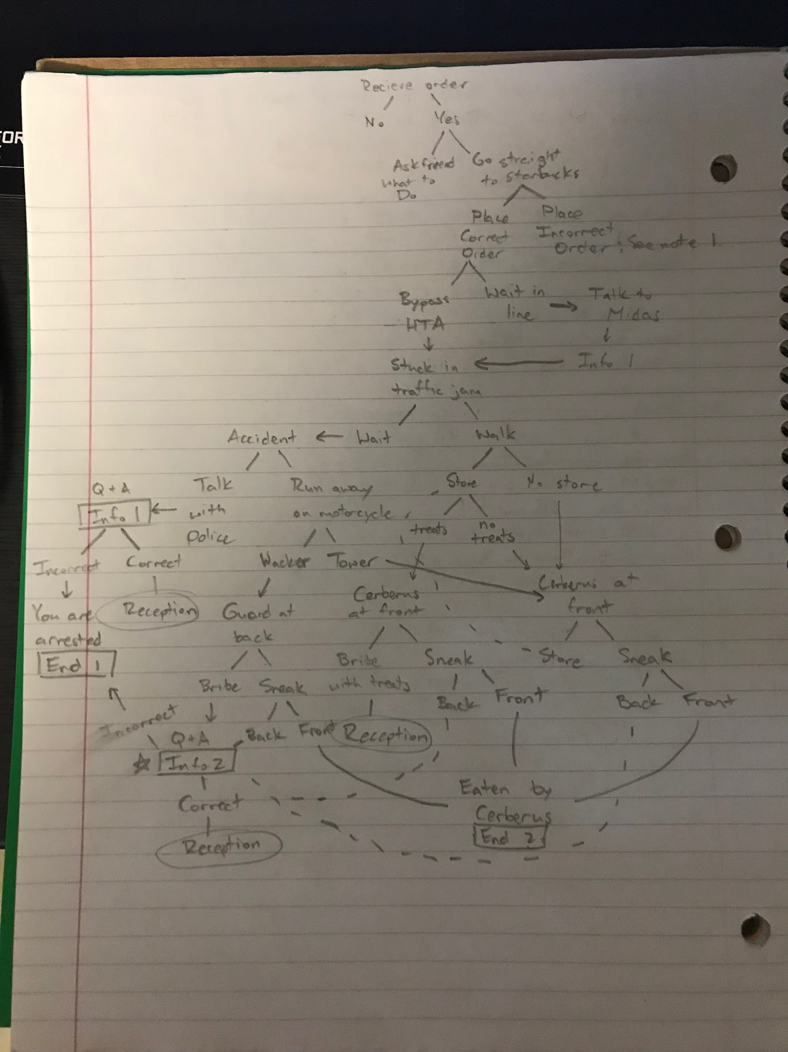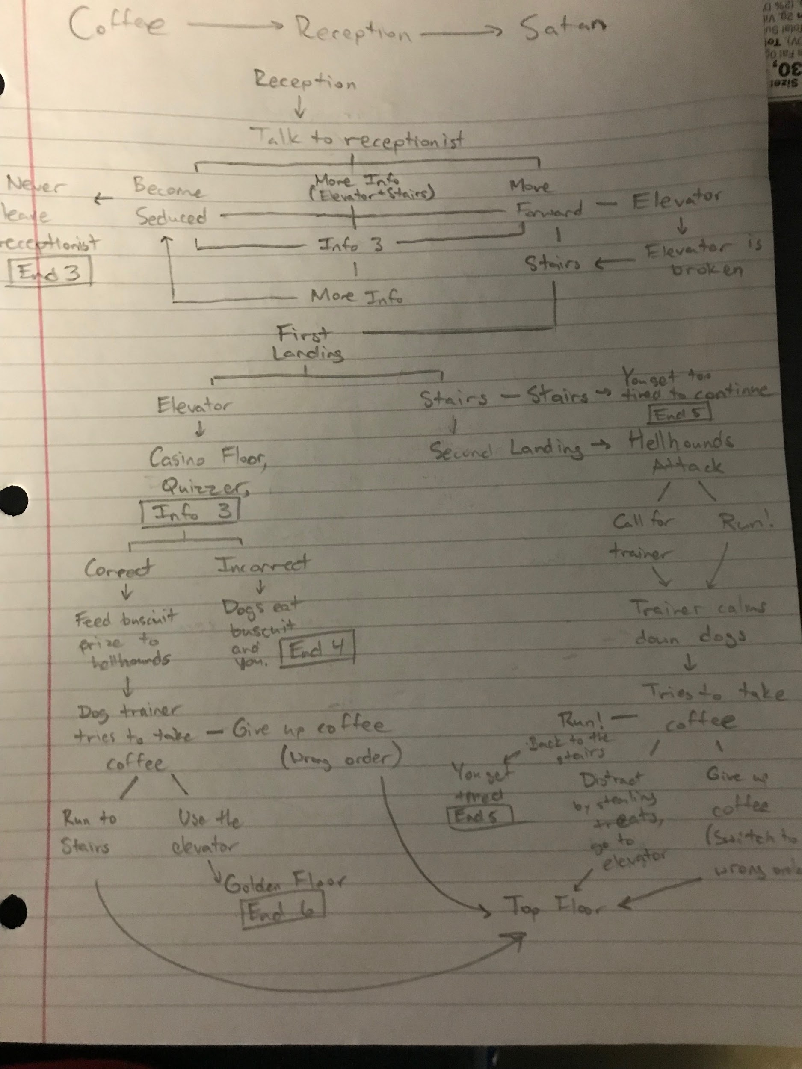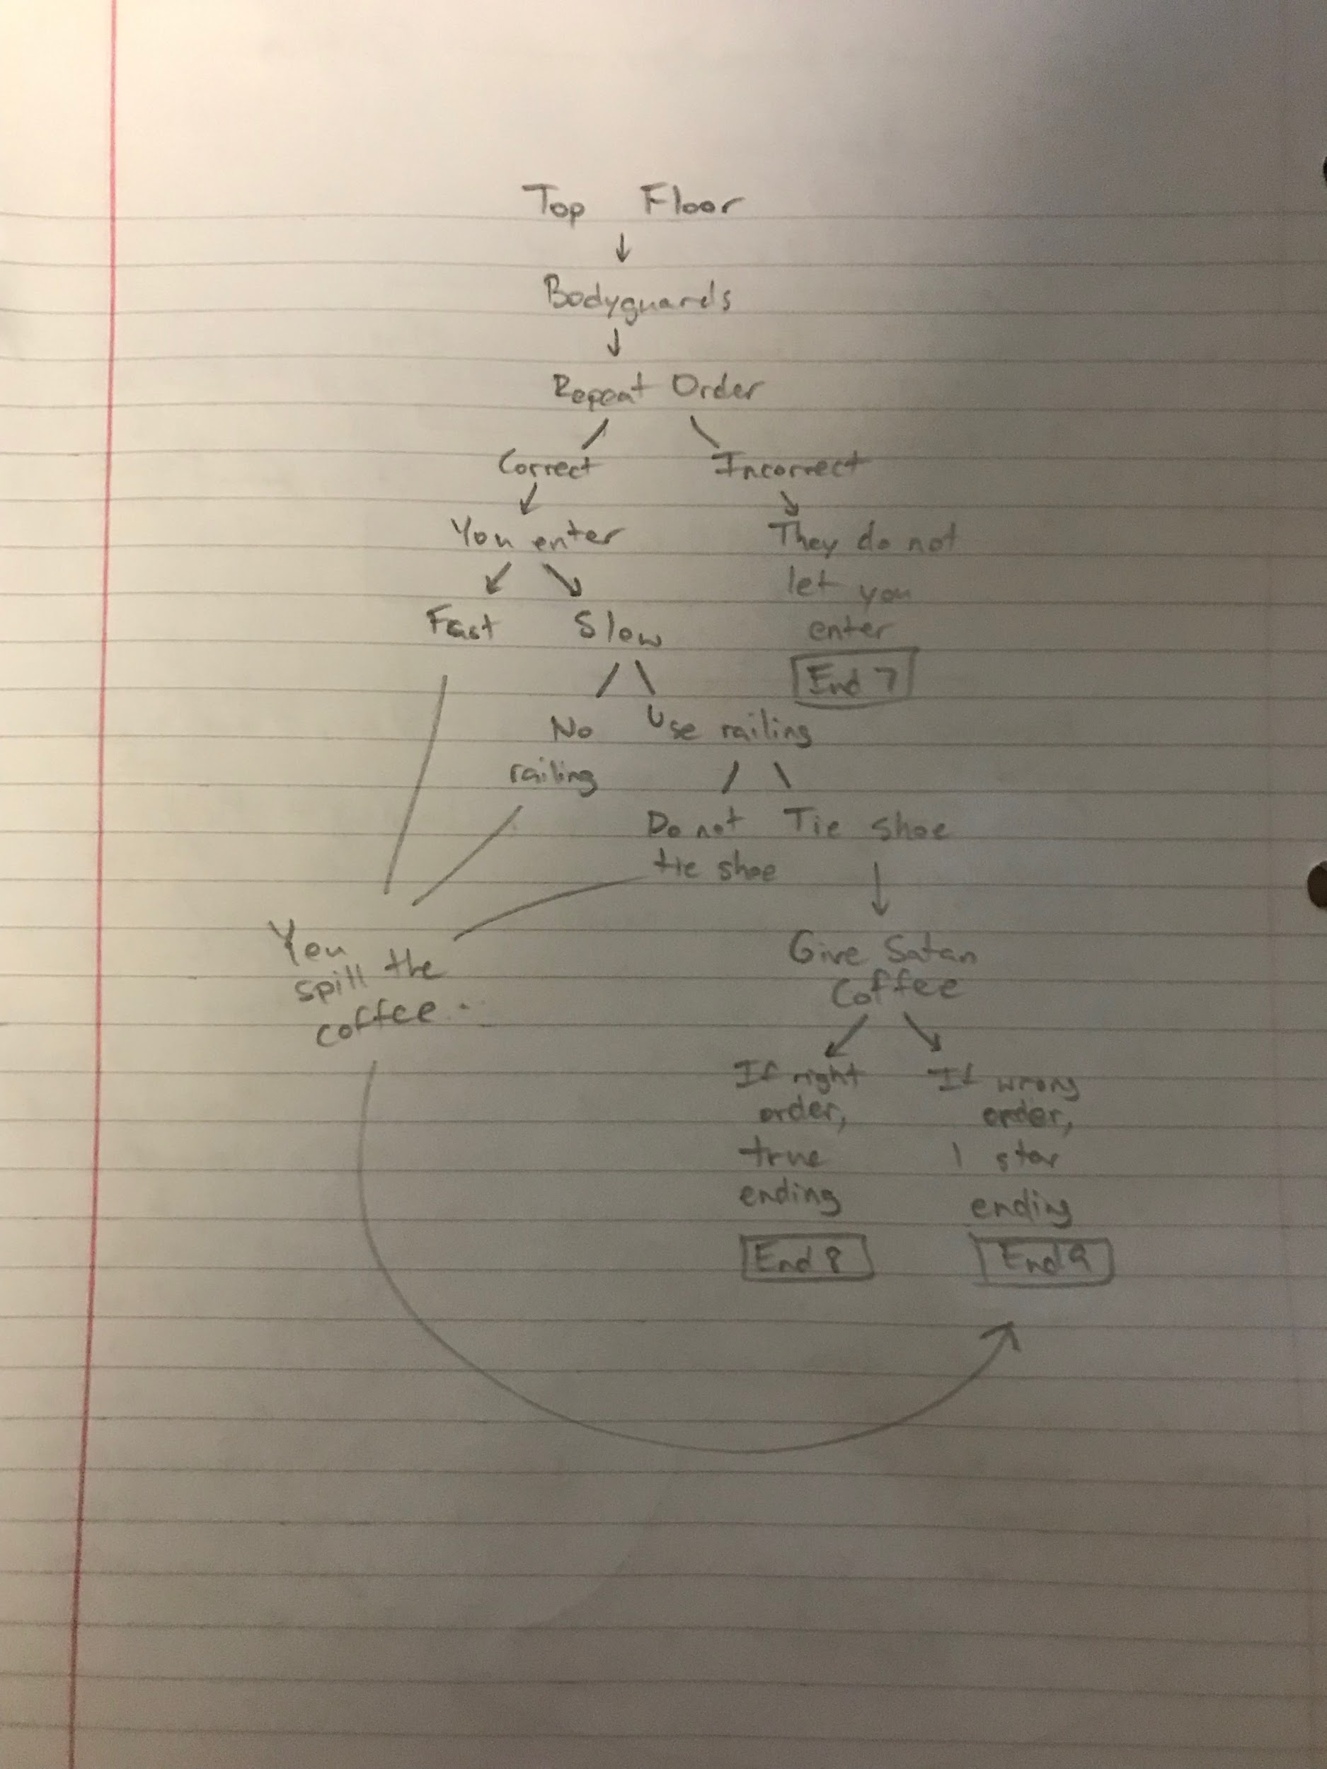

**History:**

* Hell wasn’t always as torturous as it is now. Thousands of years earlier, Lucifer and his host of demons could process each soul very quickly through Hell so they could continue on to their appropriate afterlife.
* As time went on, the queue of souls waiting for their next life grew longer and longer. The city in Hell rapidly got overcrowded, and souls started getting upset and angry.
* Hell dropped its sacred front, meaning they quit speaking latin and practicing magic meant for trickery and fun, and got down to business. Demons with latin names decided to rename themselves what they thought were appropriate to the time period. The only way Lucifer could catch up with the vast number of souls entering his domain was if he optimized everything. Demons speak in vernacular, not latin. Learning new curses and spells aren’t as important as filing new paperwork. The population is so large, most demons don’t even file paperwork; their job is to maintain the city, run restaurants, fix cars, and operate in a city just like the living do.
* Lucifer doesn’t always live in Chicago. He travels around the world, visiting the densest centers of population to help with productivity. However, Chicago is the first location he’s opened up to the living, simply because the sculpture “Cloud Gate” was too ironic to *not* establish it as a gate to Hell.
* Hell wasn’t always accessible to the living from Chicago. Lucifer is going through a phase where he’s fascinated with the Startups in the living world. In an attempt to support them, he wants to open up Hell to give them their business.
  + Lucifer sends a demon to possess a POM Wonderful worker when a batch of pomegranate juice is being shipped out. The juice functions similarly to Persephone’s pomegranate that allows her to visit Hell from real life. Lucifer starts his support by ordering through Postmates and sending them to the Cloud Gate sculpture. There, his assistant, King Minos, assists them through and explains to the living where Lucifer can be found and why they shouldn’t fear Hell
* Naturally, once people discovered Cloud Gate was a portal to Hell, they were attracted to it to figure out more. Lucifer felt threatened by this, so he told King Midas, his financial advisor to purchase the rights Millenium Park daily for a “private event.” Midas can turn anything he touches to gold, so he quickly accumulated enough wealth to pay the government for privacy from the public, reporters, and scientists alike.
  + Upon first thought, this might look like the beginning of a massive inflation rise, however the government is pouring all their funds into research about Hell, so the economy remains relatively stable. Once Midas runs out of things to turn to gold, he will no longer be able to keep the park private, and scientists, funded with millions of dollars, will be able to sweep in and research everything about the portal. For now, though, the park is exclusive to Startups like Postmates, Grubhub, and Doordash.

**Magic/Technology/Science:**

* The afterlife exists as a “flavor” of reality. This means things exist with similar, if not identical functionality to life, but the style and concept of these objects relate to a theme that extends through the whole afterlife.
  + Much like real life, the style and theme of the afterlife is built by the ruler and its inhabitants. But, different from reality, the style is greatly affected by the mood and thoughts of the inhabitants, as the realm it is more closely associated with the power in untethered souls
  + Enough souls feeling the same way can be as powerful as a king of Hell
  + Spirits of the afterlife can will things into existence and are more powerful because they’ve only lived in this thought-dependent reality and never been tied to a body
* Magic doesn’t take any physical exertion it’s all mental. However, it requires concentration on a single action or thought, which by its nature, compels the magic user to think of something else. A good example of this concept is eating. You can eat for a bit, but after a while you definitely don’t want to eat anymore. Using powerful magic takes the willpower it might take someone to eat three whole pizzas.
* Lucifer is the most powerful and can possess people, torture them, and burn them to ash with sheer willpower. However, he is too busy to do much of that anymore.
  + His lords of Hell, mostly demons with names, are slightly less powerful. They can do one of Lucifer’s many powers, but it takes a lot of energy and willpower. They, too, don’t have much time for magic anymore, and they know if Lucifer catches them using magic instead of working, that they’re in for some serious punishment or deranking, which means less powers and the closer they resemble helpless human souls
    - Human souls are the weakest spirits in Hell. They cannot intentionally perform magic. However, they are able to bend Hell’s reality through mob mentality. Demons were originally given powers to combat this odd property about souls.
    - Human imagination is what grants souls the ability to shift reality. While humans are alive, the imagination is contained within their minds, and so the real world isn’t manipulated at all by human thoughts. All that can be manipulated by imagination is an individual’s perception of reality. For example, a scary dog can seem bigger to an individual, even though science can objectively measure its size.
    - When souls exit their bodies, the divide between perception and reality is taken away, and what souls can imagine no longer warps perception, it warps reality. Hell, a world filled with souls that project their imagination onto it, bends to the most common imagined themes about it. Back to the dog example, if a scary dog looks bigger to an individual, it actually is bigger. The reality of Hell ignores most of the individual cases, until trends start occuring. If many people think a dog is big and scary, the dog becomes big and scary
      * This is how Lake Michigan became made of lava, how the concrete in all the buildings became brimstone, how the weather is always icy cold, and why the Cubs always lose. When souls enter Hell, they think to themselves something along the lines of, “Oh no, I’ve made it to Hell! I wonder how they’re going to torture me.” Among all these vivid imaginations, several commonalities in torture and atmosphere stand out. People hate the cold, so Chicago is terribly cold. People expect fire and lava, so the lake and the river are lava. People expect black castles, so the skyscrapers have battlements built with black cobblestone.
      * The worst part about soul’s imagination is that it’s uncontrollable. So Hell wouldn’t be so torturous if the legends about it weren’t so negative

**Culture/Societies:**

* All demons are subservient to Lucifer. They know if they step out of line and use their powers for unnecessary chaos that Lucifer can and will annihilate them. However, many get along just fine milling around the city like the living do.
  + Demons don’t have time for making Startup companies. Most demons help with Lucifer’s business. The little shops that populate the city outside the main soul-processing business are very Hell-centric. There’s police which maintains the chaos that breaks out frequently. There are many many pop up shops that aim to scam the souls and demons of Hell for fun. On top of that, there are some serious businesses in Hell that help assist demons with the transition to modern Hell. There are horse stables for old demons like the Horsemen of the Apocalypse.
* Demons do differ from humans in several ways. Specifically, demons’ sense of humor is very destructive. Demons like slapstick to the extreme.
* Humans are very upset about the gates of Hell, so the government is trying to use the press to cover it up while the government funds scientists to research Hell safely. At the moment, they are very hesitant. King Minos has threatened the government with chaos (under Lucifer’s permission), and King Midas pays them off.
* Meanwhile, the living are perturbed, but the mania has died down about the gates opening. By the time this story takes place, the gates have been open for a little under a month. Nothing bad has happened. The only real consequences following the opening of the gates is a new cycle of memes.

**Characters:**

**Cole (Player) →** Cole grew up in the Western suburbs of Aurora. He was a track superstar in highschool, then graduated from IIT with a Bachelors in Mechanical Engineering. After college, decided to take up a job with Postmates while he was on the hunt for a job. He is 23, around 6 ft and slim build. He enjoys listening to alternative rock music and playing twine games in his spare time.

**Lucy () →** The Lord of Hell. Lucifer is the spitting image of Johnny Depp but red and with horns. He wears a Metallica t shirt with ripped jeans and a blazer and Harry Potter style glasses. His favorite breakfast is a venti, pumpkin spice latte, (*His story is explained in the History above.*)

**Lisa (Barista) →** Lisa is a barista at Starbucks who dropped out of highschool. She lives check to check and is always trying to just make ends meet. She has been working for Starbucks for a couple of years when the gates of hell opened. She never cared too much about the gates opening. Sometimes she thinks it would be interesting to go visit one day. Lisa is a 5ft 5in woman who is 25. She is caucasian with brown hair that's been dyed black. She wears a short spiked choker, a nose ring, and goth style makeup. She likes to paint and sing but no one knows. It’s her secret from her other goth friends.

**Virgil (GPS voice) →** Virgil was a Roman Poet who led the legendary Dante through Hell, but now works for different companies as a voice interface for mapping software such as Google Maps and the maps for Postmates. His voice was deemed as attractive so it was easy for him to get the job.

**King Minos (TSA like guard) →** King Minos was the judge of the undead over in Greece. He governed who went where in the underworld. After hearing about what was going on over in the American sector of the underworld, it was a good chance to travel and change up his boring routine back home. So Minos packed up his bags and headed to AMERICA! He now works as the gatekeeper for hell in Chicago and loves to mess with the mortals, giving them a hard time. He walks around 7 ft. tall and wears clothing similar to a TSA.

**Karen (Cop 1) →** Karen was once a human but she complained to so many managers that her soul was taken to the deepest parts of hell, where the ruling demons decided to use her as a torture tool and turned her into a demon to work as a cop on the police force.

**Kyle (Cop 2) →** .Kyle whose original name is not pronounceable because it’s in demon tongue was one of your average soul torturing demon until he watched some human cop movies and shows. Now he wishes to be in car chases and crazy fights but at the moment he is stuff in his regular 9 to 5 giving tickets for speeding.

**Skelly (Hell shop owner) →** Skelly is a skeleton pet shop owner. He knows how to tame ALL of hell’s adorable creatures...or so he claims.Skelly is one of Lucifer’s private friends who gets into Lucifer country club sometimes to play golf using zombie heads. Skelly loves creatures more than people since they don't stab you in the back or run away from you in fear like humans do. Skelly is very happy go lucky and nonchalant with its actions as long as the creatures it tends to are okay and humans are suffering.

**Joe (Security Guard backdoor) →** Joe is a human whose face was so so putrid and disgusting that he was mistaken for a demon that somehow got into the human world and was forced to guard the back door for all eternity as punishment for coming into the human world without permission.

**Shayla (Succubus Receptionist) →** Shayla was in charge of the 2 circle of hell for lust. Due to the influx of souls, Lucifer put her at the front desk to help make dealing with people much easier due to her charms. Shayla in her free time likes to seduce humans and take their life force.

**Ricky (Elevator Gambler Guy) →** Ricky is a mischievous demon. He is normally drunk and stumbles around causing problems for those around him. He is an overweight mess that wears a tattered suit that always have food stains on them. His breath smells like a fresh can of spam. He doesn’t have any spectacular traits except stuffing his face so his boss, Jack just placed him next to the elevator to guard it.

**Kathleen Vera (Hellhound Trainer when climbing the tower) →** Kathleen cares about one thing and ONE thing only! Her beautiful, amazing, wonderful puppies. She takes care of Lucifer’s personal hellhounds and Cerberus. She resembles a human but with red skin life Lucifer. She wears her hair in a ponytail and has horns. A great afternoon for her is sending souls to run into the depths of hell while she hunts them down with the hounds. Then have lunch while the hounds gnaw on their bones. Then have dinner with Mr. Lucifer himself. She finds Lucifer to be a great leader and sucks up to him but will never admit it.

**Biscuit and Gravy (Lucifer Bodyguards) →** Biscuit and Gravy are demonic tanarukk that act as Lucifer’s personal bodyguards because of their level of intimidation from their hulking size and mean demeanor. Biscuit and Gravy were greater demons from Lucifer’s mighty Legion who helped during the Battle of Marathon.

**Jack (Demonic Gambler) →** Jack realized that pushing paperwork was not his thing as the prince of greed so he decided to help his demons take a load off by opening a casino inside Lucifer’s building. Now he can continue to take money from the poor souls who manage to stumble their way in.

**Derrick (Cole’s Friend) →** Derrick is Cole’s friend from highschool who was on the football team. Derrick wasn’t as physically gifted as Cole, but good at sports nonetheless. In his free time, he would draw landscapes and people. He ended up going to IIT as an architecture student and works at a nearby firm in Chicago as an intern.

**Dialogue/Script:**

Dialogue/Script → Luis/Cole

Bing! Your phone tells you that you have a notification. “Please not an order,” you think as you pick up your phone. As a GrubHub driver full time, you constantly get orders to deliver, but you hate the early morning deliveries. Maybe your friend sent you a message? [[Maybe?]]

Nope, it’s GrubHub. You look at the address and freeze. It’s for Lucy. Every Grubhub driver’s worst nightmare. Perhaps you haven’t been to Chicago recently, but everyone knows now that the man who goes by Lucy is Lucifer, and Lucifer is Lucifer. Satan himself. He wants it delivered to his office… in Hell-Chicago. On the 666th floor of the Sears Tower. He wants a macchiato with a little whipped cream, along with an avocado toast from Starbucks. Better remember that…

[[Or not, someone else can take it]] [[I need help…]] [[Let’s go to Starbucks!]]

You hop into the shower, get dressed, and start making your way to Starbucks. Traffic is light, and you make it there pretty quick. You walk into the [[store.]]

There is a long line. Finally, you make it to the front. The server gives you a dull look. Her face is covered with goth makeup. “Welcome to Starbucks,” she sighs. “My name is Lisa. How can we help you today?” You ask her for a ー

[[Macchiato]] [[Cappuccino]] [[Coffee...Black]]

Lisa puts the order into the register, then looks up. “Whipped cream?”

[[Yes]] [[No]] [[EXTRA]]

“Is that it?”

[[Yes]] [[I need an avocado toast, too.]] [[Cinnamon roll, please.]]

She rings up your order. “$11.63…” You hand her a $20 bill, and she gives you change.

You leave the Starbucks and head over to the Hell Bean, less commonly known as the Cloud Gate. As you get to the border, you are stopped by the ever-patrolling Minos. You stare at his giant feet, still unsure of this endeavor. You are headed straight to Hell, after all.

“Passport?” Minos’s voice bellows through your car as you show your identification.

[[This is creepy, let’s skip this chit-chat]] [[Any suggestions about how to get this Starbucks order to Lucifer?]]

You decide to stay silent. “You’re the strong silent type? Won’t do you well in Hell. Head through the portal, you’re cleared.” Suddenly, the car screeches forward at highway speeds through the fiery portal…

And you end up in a traffic jam on the other side. Fire and brimstone cover the buildings… but the place is fairly familiar. You recognise the burnt grass as Millenium Park. Buckingham Fountain is on the far side of the park… spewing fire, lava, and souls of the dead. Very pleasant. More than anything, you want this trip to be over.

It seems like an eternity, but you have gotten to Adams. Still a long way to the Sears Tower…

[[Get out and walk]] [[It’ll pick up]]

Despite the wall of sound coming at you as you get out of the car from the traffic, you decide it’s for the best. [[“I’m sorry! In a rush!”]] [[“Yeah, if you knew how to drive, this wouldn’t be happening!”]]

It’s not a long walk. It surprises you how similar Hell Chicago is to regular Chicago. Look, there’s even a pet shop!

[[Stop inside]] [[Continue to the Tower]]

The bell chimes as you enter the store. A rattling sound comes from the back. You jump, startled. “What a cute doggy,” a voice says. You turn the corner to see a skeleton! The fiery dog has its arm? “Hey, I’m Skelly! You don’t seem to be dead yet! We’ve been seeing more of your kind recently,” Skelly says. “They just opened up that portal, right? Can I get you anything?”

[[I’m not interested in pets.]] [[Can I get some dog bones?]] [[Run away, let’s get out of here!]]

“Hmm… Dog bones? Don’t got any of those,” he says. “Can anything else suffice?” You look at the dog chewing the skeleton’s arm. It seems to be enjoying itself…

[[Can I have your arm?]] [[That’s too weird. There must be another way.]]

Skelly looks at you with a blank expression. Suddenly, you realize that skeletons have no way of showing expression, so he’s impossible to read. Skelly says, “Sure, I guess. Bring it back in one piece. Here,” he holds out his arm. You question your motives, but you really want the bone. You grab his arm and pull. You feel it give way as it pops out of its socket. “Don’t worry about me, I’ll get this one back as soon as Lassie decides to let go.”

[[Go to Tower]]

As you approach the Sears Tower, you see the cause of the traffic jam. Cerberus, the three-headed dog, has left his guard post and decided to take a short rest in the middle of the street. As you approach, one of its heads takes a quick look around, then goes back to sleep. You’re going to need a distraction, or you’ll need to go in through the back.

[[Sneak to the back of the building]] [[Try to sneak past Cerberus]] (([[Throw Skelly’s arm]]))

“Hey Cerberus! Over here!” All three heads look straight towards you as you hold up the arm. Cerberus’ heads let out the most annoying little choir of yips, and he gets up and runs toward the arm. You throw it down Franklin Street. Running through the street and jumping over cars, you expertly both dodge Cerberus and balance the coffee cup to make sure it doesn’t spill. Guards run past you, screaming, “No, Cerberus! Down! Stay, boy!”

[[Let’s get into the tower]]

Entering the tower, you see fire and brimstone. Obviously, the stuff is everywhere. But other than that, it seems surprisingly mundane. Your eyes meet the receptionist, a beautiful woman in a sexy red dress. Or, you think it’s a woman until you see the forked tail swing up over the counter. “Why, hello, cutie,” she smiles. “I’m Shayla, your name?” You explain that you need to get the coffee order to Satan.

“Well, isn’t that nice, for you to deliver him his coffee. Why don’t we get to know each other?”

[[I’d like to get to know you in the bedroom…]] [[What’s the fastest way to the top of this Tower?]]

“Well, the elevator down here is broken, so you should probably just stay here,” she quips. “Don’t you think you would be happy with me? Of course, you might be happier if you took the elevator up twice, then you’ll be stuck in the gold room for eternity. But it’s better here than if you take the stairs twice!” That actually might be useful advice…

[[Maybe I will stay here. You are just so beautiful.]] [[What can you tell me about Satan before I meet him?]] [[This is enough, if I stay here, she might convince me to stay forever!]]

She leans in very close to you. You have a clear view of too much. “Well, you like the big boys, hm? Well, he told me once that I was his favorite receptionist. He really likes my red dress,” she whispers, gesturing to places you don’t want to look. Although I guess Satan likes red dresses…

[[Maybe a glance won’t hurt anyone…]] [[I need to get out of here]]

“Bye, thanks for your help,” you say as you turn away. “I’ll leave you a good review!” You call back. She seems disappointed.

[[Go to the elevator]] [[Go to the stairs]]

You approach the elevator, but Shayla calls up, “Broken!” Yep, she’s definitely disappointed. You go to the stairs.

[[Go to the stairs]]

You climb the stairs. All of 33 flights. Finally, you see a sign, “Elevator this floor” Finally, a break. You hear people talking many loud sounds, like a casino.

[[Leave the stairs]] [[More stairs!]]

You suck. Why would you make me climb up more stairs? Whatever. You climb up the stairs, all the way to the 66th floor. You feel exhausted, and climbing more stairs seems impossible. You hear… puppies? You think there are puppies on the other side of the door.

[[Get off on the 66th floor]] [[Continue up the stairs]]

You open the door, and hellhounds are running amok! They are so excited to see you! They all run at you… at the same time.

[[Defend yourself]] [[HEEEEEEELLLLLLLPPPPPP!!!!!!!!!!!!!!!!!!!!!!!!!]]

Just as you think you’re about to be dog food, you hear, “Down, down. You’ve all seen demons here before.” Then, a demon turns the corner, giant horns out in front, and bite scars across both arms. The dogs calm down. “Oh, a human! I’m Vera. Kathleen Vera. And you brought me coffee! How thoughtful…”

[[No, it’s for Satan]] [[I just want the elevator]] [[Oh, here you go.]]

“Certainly, you can donate to the demon who saved you from a violent death by hellhounds…”

[[You need a distraction; steal some dog treats]] [[Give up the coffee]] [[Go right back to the stairwell; You really want me to be tortured in Hell…]]

You steal some dog treats, and throw them down the hall. Just like a regular dog in the park, all the puppies raced to grab the treats. “What did you do!” Vera scrambles to calm all the dogs down. You use the opportunity to find the elevator. Some of the flames coming off the hounds singe your jeans, but at least you found the elevator. You push the top button, labelled “Satan’s Office: Top Floor.” Here we go…

[[Top Floor]]

You get to the top floor, and a red velvet carpet leads from the exit to the doors of Satan’s office. On either side, two hulking demons, each at least 8 feet tall stand, armed with flaming spears. The horns on their heads curled up to a sharp tip, ready to impale anyone who opposed the all-mighty Satan. The business suits killed the look, though, and made them appear much smaller. You read the nametags on their chest. Biscuit and Gravy.

“You shall not pass,” Biscuit says. “What is your business here?” Gravy asks. You explain that you just want to deliver Satan his coffee order. You’ve already been stuck in a terrible traffic jam, got attacked by hellhounds, and climbed way too many stairs. They seem unconvinced.

Gravy steps forward. “To convince of your true intentions, we ask of you, what was Satan’s order at Starbucks? Biscuit asks, “He always orders the same thing. We know what it is. What type of coffee?”

[[Macchiato]] [[Cappuccino]] [[Coffee...Black]]

Gravy lowers his spear, ready to strike at any false answer. “What about whipped cream?”

[[Yes]] [[No]] [[EXTRA]]

Biscuit jumps at you, stealing the order! “We can’t have you peaking! What else did he order on the side?”

[[Nothing]] [[Avocado Toast]] [[Cinnamon Roll]]

You answer all the questions, and Gravy raises his spear. Biscuit hands back the order. “You have done well to make it this far. Be careful as you enter. This is a room of misfortune. Many have failed in this last step.” They open the door, and Satan is sitting at a desk in the back of the room. Such little distance left to travel.

Should you rush to him with the order?

[[Yes]] [[No]]

There is a small staircase. How many stairs do you take at a time?

[[1]] [[2]] [[3]]

You notice that your shoe is untied. Do you stop to tie it?

[[Yes]] [[No]]

Finally, you reach the desk. Satan looks up at you. He’s… not what you expected. “Hey, man. You can call me Lucy.” He looks at you through his round sunglasses, but all you really look at is his Metallica T-shirt. It seems like its about to rip off, yet it also seems rather old. He takes a sip of his coffee, and says, “Ah, what a drink. Hard to find reliable service, ya know, man? That’s why I only trust the living with my coffee. Avocados don’t grow well here, so we used to import from heaven. But now with the portal, we can get them from you guys.” He takes another sip.

[[Um…]]

“Oh, totally, man. Almost forgot. You probs want to go back to regular Chicago. Here,” he stands up. “Hey, really man, I couldn’t thank you enough. I’ll put in the good word for you. You really shined today, bro. Come back anytime!” Satan waves his hands around, as a red pentagram forms in front of him. You prepare to embrace death itself, but all you feel is a sudden rush of wind.

[[Woah!]] [[Noooo!]] [[There’s no place like home, there’s no place like home…]]

You open your eyes and you’re in front of Starbucks! In your car… somehow? At this point, it doesn’t matter. You made it to Hell and back! Congratulations! You really are a master within disaster!

You text your friend, Derrick. He responds, “Holy cow, you’re amazing! OMG! How much tip did you get?” You reach into your pocket to find… exact change. You open the GrubHub app to find that Satan left a 5 star review! Orders begin rushing in for you to deliver. All of them are going to Hell. At least you’re busy!

The End

-- Casino Subplot --

You climb the stairs. All of 33 flights. Finally, you see a sign, “Elevator this floor” Finally, a break. You hear people talking and the many loud sounds of a casino.

[[Leave the stairs]] [[More stairs!]]

You open the door and are assaulted (not literally) by the lights and sounds of a massive casino. Everywhere you look are demons and devils of varying shapes and sizes. You squeeze between demons much larger than you and tiptoe over demons much smaller than you. All the while, you pray not to get bumped the wrong way to spill the coffee!

As you make your way past the roulette wheels and slot machines, you finally see in gold lettering the word “Elevator” and a sign pointing left. As you turn the corner, you nearly run into someone. When they turn around, you see Lisa, the barista from Starbucks. You ask, “What the hell are you doing here?”

She pulls the choker on her neck, then touches her nose ring. “Hey, look at that! I transformed!” You try to sidestep her, but she won’t let you by. “Hey, why don’t we make a deal. You’ll give me your soul if you can’t answer my questions, and I’ll give you a prize if you can. Sound like a deal?”

[[Run past her]][[You can answer these questions!]]

“OK, great! What color dress does Satan like?”

[[Red]] [[Blue]] [[Sexy Black]]

“You probably don’t remember the name of the receptionist downstairs do you? The sexy devil?”

[[Nicole]] [[Darlene]] [[Shayla]]

“Wow, you got all the questions right! I didn’t think you’d be able to answer those.” She looks in her pocket and pulls out a bone. It looks like it might be a rib. “Here, take this. If you end up on the 66th floor, it might be useful.” She winks at you, then suddenly transforms into a doppelganger of you! But she, he, it? It walks away.

You continue on to the elevator and find that the highest floor this elevator goes to is the 66th. How convenient, you think, and head up.

[[To 66th floor]]

“Ha, wrong, wrong, wrong! But I won’t take your soul. Why don’t you just skirry along, this game was fun! We should do it again.” Lisa runs off, leaving you no time to tell her that you have no intention of coming back. Oh well.

You proceed to the elevator and hit the top button. Unfortunately, it only takes you to the 66th floor. The doors open, and without paying attention, you step out of the elevator, hurrying toward your next destination. Suddenly, you realize that your way is blocked by hellhounds. They growl, and you call for help. No one comes, and the dogs rip you (and the coffee) to shreds.

The End

The elevators open, and you try to figure out how this bone will help you. There are dogs everywhere. As you step out of the elevator, you see all their eyes lock on to you, and they start barrelling toward you. Suddenly, you realize that their eyes are on the bone, not you! You throw the bone down the hall --

[[To get to the stairs]] [[To get to the elevator]]

The hellhounds run away down the hall. A voice behind you says, “Ya know, I could call them all back here to deal with you. I train them, after all.” You turn around to see a demon with huge, bull-like horns curled around her head. “Why don’t you give me the coffee, and I’ll let you run along. How does that sound?”

[[OK, you can have the coffee]] [[Wait, no! Let me get to the stairs]]

“Thanks,” she says. “You can call me Vera.” She takes a sip. “Ah, tastes great! Love a good coffee.” She looks to you. “That’s enough, run along now.” You don’t question it twice. To the stairs.

[[To stairs]]

“I didn’t want to have to do this.” The demon roars, and you feel the heat of the hellhounds lighting themselves on fire. Quickly, you look for another distraction. Almost as an instinct, you reach for the dog treats wrapped around the hound trainer’s waist, and the trainer doesn’t react fast enough. Throwing the treats distracts the dogs, and the wall of the room catches on fire. “No, buttercup, stop that!” The dog trainer seems thoroughly distracted by the rampaging hellhounds and burning room. You quickly slip into the stairwell.

[[To stairs]]

You attempt to run past Lisa, but you feel a chill inside yourself, despite how hot it’s been since you got here. “I can just take your soul, too.” You turn around, and see that Lisa has an arm around a ghostly version of you. “Give me my soul back!”

“Answer my questions, and I’ll give it back, K?”

--Accident--Police

And you end up in a traffic jam on the other side. Fire and brimstone cover the buildings… but the place is fairly familiar. You recognise the burnt grass as Millenium Park. Buckingham Fountain is on the far side of the park… spewing fire, lava, and souls of the dead. Very pleasant. More than anything, you want this trip to be over.

It seems like an eternity, but you have gotten to Adams. Still a long way to the Sears Tower…

[Get out and walk] [[It’ll pick up]]

After waiting for such a long time you decide to stick it out, it couldn’t possibly be worse than trying to make it on foot in hell. Seconds keep passing and passing (and passing and passing and passing), and you start wishing that anything could happen to keep you from dying of boredom.

“Clack” Car crash noise*

Like a genie, hell has turned your wish into a reality as you are rear ended by a teenage demon texting on their phone who as far as you can tell hasn’t even notice it happened.

[[Talk with Police]][run away on a motorcycle]

“Well well well, what do we have here”-Kyle. “Get over here rookie, it looks like we have a criminal in our hands” - signaling to Karen

“License and registration, human” Kyle lazyly asks you while waiting for Karen to arrive

“Mmmm mmmm mmmmmmmmmmmm, yet just as I thought this is an Illinois driver's licenses, we don’t take these here, Karen cup him”

Fumbling you try and explain that you you are just here to deliver so coffee for Satan

“O so you think you are suck a hot shot just cause you're delivery coffee for the big man, well then I am sure you wouldn't mind answering some basic questions to prove that you know your way around here”

-Quiz 1-

“How many floors are in Hell’s Sears Tower?”-Kyle

[[9]] [[110]] [[666]]

“Who is patrolling the gate to Hell”-Kyle

[Demons][Minos][Baul Plart Mall cop]

“What's the name of the artist featured at the Art Institute of Hell right now?”-Kyle

[[Dan Peterson]] [[Picasso]] [[Georgia O’Keeffe]]

[[Answer all correct]][one wrong answer]

“Mmmm I guess you’re legit, let's get you to the reception before Lucifer blames us for holding up his coffee.”

[Proceed to Reception storyline]

--Alternate Accident Police ending--

[Answer all correct][[one wrong answer]]

“Looks like we bagged ourselves a criminal and got some free coffee out of it, looks like it a good day to be a cop in hell”-Kyle

--Accident--Motorcycle

And you end up in a traffic jam on the other side. Fire and brimstone cover the buildings… but the place is fairly familiar. You recognise the burnt grass as Millenium Park. Buckingham Fountain is on the far side of the park-- spewing fire, lava, and souls of the dead. Very pleasant. More than anything, you want this trip to be over.

It seems like an eternity, but you have gotten to Adams. Still a long way to the Sears Tower…

[Get out and walk] [[It’ll pick up]]

After waiting for such a long time you decide to stick it out. It couldn’t possibly be worse than trying to make it on foot in hell. Seconds keep passing and passing (and passing and passing and passing), and you start wishing that anything could happen to keep you from dying of boredom.

“Clack” Car crash noise*

Like a genie, hell has turned your wish into a reality as you are rear ended by a demon teenager texting on their phone who as far as you can tell hasn’t even notice it happened. Immediately, about four cars in front of you, sirens blair and you see two cops exit the vehicle.

You look at your options. Obviously, you can talk with the police, but how does the legal system in hell work? You didn’t even know there were police in Hell five minutes ago. There’s a demon on a motorcycle next to you, though. Maybe you can steal it?

[Talk with Police][[Steal the motorcycle]]

You decided to bolt before they hold you up and you lose more time. You get out of your car and run over to the motorcycle. You quickly jump on the bike and bolt out of there. Which direction though? You figure you could head straight to the Tower, or you could loop around to the back on Wacker.

[[Tower]] [[Wacker]]

You turn away from the cops towards Wacker Drive. The cops go to chase you, but the traffic is way to tight. Their car can’t even move. Your motorcycle, however, moves right between the cars, allowing you to escape.

You pull around to the back of the Sears Tower, but you find that a guard is standing in front of the back door. You might be able to convince him that you need to see Lucifer, but he might just throw you in jail. Maybe you can try to sneak in through the front?

[[Bribe]] [[Sneak]]

As you approach him, you realize that this is a real person, an actual person! He’s really, really ugly, and you remember seeing a story on your news app of someone getting sent to Hell on accident for misidentification as a demon. “I’m delivering a coffee to Lucifer, Satan himself.” Suddenly, the guard looks surprised. “To Satan? Surely not, no, no. If you were, you were delivering to Satan, he would have taught you about Hell. If you can answer my questions, I’ll let you in. Otherwise, I’m calling the police. Maybe I can get out of here!”

-Quiz 2-

“Most demons prefer coffee from which coffee shop?”

[[Pete’s Coffee]] [[Dunkin’]] [[Starbucks]]

“The Hell Bean is known by another name. What is it?”

[[Cloud Gate]] [[The Great Portal]] [[There’s another name?]]

“What shoots out of Hell’s Buckingham Fountain?”

[[Blood]] [[Water]] [[Fire, lava, and souls of the dead]]

“Dayummm you are good, I bet even the great sphinx would let you through” Out of Character

“You answered them all right! I thought they were hard!” The guard breaks down, crying. “I was hoping this act would get me back to the real world,” the guard says. “Don’t worry, I’ll get you into the building.” He opens the back door, wipes his eyes, and says, “Good luck, put in a good word for me with Lucifer. Also, say hi to Shayla for me.” You enter and find yourself in the reception area, wondering who Shayla is.

-Proceed to reception-

--Gets One answer wrong before the last one—

“Sorry, can’t let you through. Wait a minute, is that motorcycle even yours?’

-go to jail

--chooses to insult the guard—

“Hey that's not fair! I put a lot of effort into those questions”- they say as they are tearing up

Hearing the guard crying the cops find you are arrest you for disturbing the peace

--go to jail for being mean—

--Wacker Sneak—

Knowing that there is a back door at wacker you head there to try and lose the cops. As you arrive to the wacker backdoor thankful that were were able to avoid the cops, you are surprised to find a guard station there.

[Bribe][[Sneak]]

Not trying to press your luck, you decided to try and sneak in instead.

[[Back]][Front]

As you try to sneak through the back you are caught by the guard got very excitedly suggested you answer some questions if you don’t want to get in trouble.

-go to Quiz 2-

[Back][[Front]]

Deciding it better to avoid the backdoor because of the guard you sneak your way to the front

-go to eaten by cerbours-

-- Death by Elevator --

You get to the elevator and quickly jump in. The doors close, and you feel safe. You feel a little guilty, using the elevator twice. Did you really put much work into this? The doors open and you step into a room filled with gold. Towers of gold as far as the eye can see. Greed overtakes you, and you have to take a closer look. You step out of the elevator and run your fingers through the endless amount of golden coins. It is truly incredible. You put a handful into your pocket, then turn to enter the elevator again. But the elevator is gone.

You cry for help, but all you hear in return is a voice. “You have succumbed to greed, taking the elevator twice. How easy did you think it would be to get to the top of Hell’s Sears Tower? It is truly too easy to lure mortals to my realm.” You are stuck in a room of gold, forever. You cannot escape. But at least you have a golden swimming pool filled with golden coins in a golden mansion.

-- Friend --

You call your best friend, Derrick. “Dude, I just got an order from Lucy!”

“OK, calm down. You’ll be fine. Some people make it back,” he says. “Just make sure you’re paying attention to what people are saying. I’ve heard that demons love asking questions about random demonic hell stuff, so keep every detail in mind. When you get the opportunity, make sure you are talking to people.” You thank him for the advice, and he hangs up. Remember everything, talk to people, you’ll get out fine. You hope.

[[To Starbucks]]

-- Minos --

“You need to get to Satan, huh? Well, lots of demons like coffee. Keep it close. I know that Satan likes Starbucks, but most demons actually prefer Dunkin’. You might be able to use that? Also, the Georgia O’Keeffe collection at the Art Institute of Hell just opened, so traffic is pretty bad. Anyway, your passport looks good. You’re free to pass. Good luck with your delivery.”

Skelly’s shop

You walk into the shop, and, seeing the puppies around, you realize it is a pet shop. You look for the owner, and he is struggling to get his arm

-- Shayla Death --

Shayla grabs your hand and leads you to the end of the desk. Excitedly, you take her hand and follow her. She leans in and gives you a kiss, letting her lips hover close to your face. You feel her warm breath pass across your face, and touch the smooth skin on her face. She leads you to the elevators, and you watch some magic sparkles jump from her fingertips. The elevator opens. Shayla pulls you in forcefully, which you find oddly seductive. She hits the top floor. The door opens, and a large bed with red velvet sheets is in front of you. Here we go, I guess. Lucy’s going to have to wait a bit for his coffee.

The End

**Mechanics/Interactions:**

* Remember info/ getting info for progression
  + Clicking buttons set variables in javascript.
* Sears Tower Floor combinations
* Getting info from Succubus
* Answer question right from Lucifer’s bodyguards about Lucifer’s order to prove that you are there to give him coffee
* Small tutorial: Get Lucifer’s order right, if wrong a notification from the app appears from Virgil overhearing you mess up the order. If the player chooses to check the notification then you can correct the order. OR you can ignore the message and continue the game with the wrong order.)
  + Status of coffee is preserved by a javascript variable
* You can gamble with the elevator guy for the dog treat by answering questions. You can double or nothing but if you lose he feels pity and gives you your stuff back, then on the way up you are mauled by dogs by panicking to get the treats out. If you win the second round he warns you about the dogs ahead of time.
  + Status of gambling successes is preserved by a javascript variable
* Possible mechanics
  + Upon death, players can return to a checkpoint instead of the beginning
  + Have angels also be in the earth world but not hell, and you have a chance to mix Lucifer’s order with a holy mocha w/ extra holy cow milk and if you make it to the end of the game with it, you kill Lucifer

**Art Ideas:**